RECTIFYING FOCAL STOCK OBSCUREIN A CYPER THEORY

Preface

TABLE OF CONTENTS
1. SOFTWARE DEVELOPMENT LIFE CYCLE
2. PLATFORM KNOWLEDGE
3. ABOUT PROJECT
3.1 ABSTRACT
3.2 SCOPE OF THE PROJECT
3.3 EXISTING SYSTEM
3.3.1 DISADVANTAGES
3.4 PROPOSED SYSTEM
3.4.1 ADVANTAGES
4. BOTTOM LINE AND FUTURE ENHANCEMENT

5. SOFTWARE AND HARDWARE REQUIREMENTS

1. SDLC (Software Development Life Cycle)
The Software Development Life Cycle is a systematic process for building software that ensures the quality and correctness of the software built. SDLC process aims to produce high-quality software which meets customer expectations. The software development should be completed within the pre-defined time frame and cost.

SDLC Phases
The entire SDLC process is divided into the following stages:
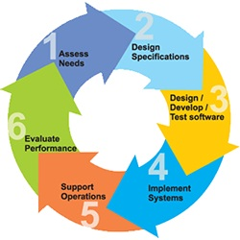
- Phase 1: Requirement collection and analysis
- Phase 2: Feasibility study
- Phase 3: Design
- Phase 4: Coding
- Phase 5: Testing
- Phase 6: Installation/Deployment
- Phase 7: Maintenance

2. Platform Knowledge
Introduction to java
Java programming language was originally developed by Sun Microsystems which was initiated by James Gosling and released in 1995 as a core component of Sun Microsystems' Java platform. Initially, the language was called “Oak” but it was renamed as “Java” in 1995. The primary motivation of this language was the need for a platform-independent language. Finally, Java is for Internet Programming where C was to System Programming.

Java architecture
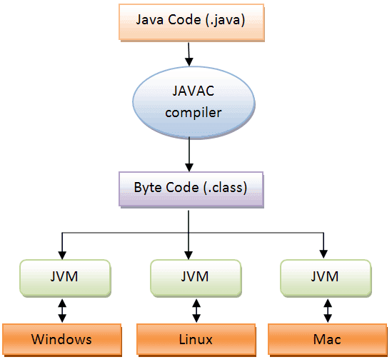
Java is a high-level Object-oriented programming language. A program written in high level language cannot be run on any machine directly. First, it needs to be translated into that particular machine language. The javac compiler does this thing, it takes java program (.java file containing source code) and translates it into machine code (referred as byte code or .class file). Java Virtual Machine (JVM) is a virtual machine that resides in the real machine (your computer) and the machine language for JVM is byte code. JVM executes the byte code generated by compiler and produce output. JVM is the one that makes java platform independent.

3. About the Project
3.1 Abstract
Computer security is important because it keeps your information protected. It's also important for your computer's overall health; proper computer security helps prevent viruses and malware, which allows programs to run quicker and smoother. Computer security, also known as cybersecurity or IT security, is the protection of information systems from theft or damage to the hardware, the software, and to the information on them, as well as from disruption or misdirection of the services they provide. Malware is software that is intended to damage or disable computers and computer systems without the owner’s knowledge. Malware is the shortened term for “malicious software,” and it typically is characterized by the intent of the creator rather than by its features. Various types of malware exist, including spyware, viruses, worms, Trojans, and other types of malicious code that can infiltrate computers.As malware attacks continue to grow in both frequency and sophistication, it is becoming increasingly difficult for enterprises to defend against them. The most serious malware attacks combine stealth, precision, and social engineering techniques to penetrate and compromise systems. When these cyber threats make it into a system, they steal proprietary data transmitted over corporate and classified networks, often causing serious damage before they are detected.
3.2 Scope of the project
A warehouse is a building for storing goods. Warehouses are used by manufacturers, importers, exporters, wholesalers, transport businesses, customs, etc. They are usually large plain buildings in industrial parks on the outskirts of cities, towns, or villages. The main function of a warehouse is to store products or goods before moving them to another location. But there can be some secondary functions of warehousing that enhance a warehouse's space. Warehouse management is the control of the day-to-day operations of a warehouse, such as the shipping, receiving, put-away and picking of goods. Is it the same as Stock Control? The term is sometimes used interchangeably with the 'stock control' or 'inventory control'. Warehousing is a very important part of the logistics management system. It provides storage for the finished goods and also includes packing and shipping of the order The warehouse personnel are responsible to identify, sort and dispatch the goods as soon as the shipment arrives.
3.3 Existing System
In existing system there will be leakage of data and data missing and also there will be lot of mistakes likes the intermediate between warehouse and buyer the seller can what kind of product inside the packing they easily knows and stolen the product these kind of problem rapidly repeated in many times .same buyer purchase some products but they got different product these mistakes are common thinks and mismatch the details like we reduce the mistakes we should overcome certain things.

3.3.1 Disadvantages
- By this existing method the files are malware and virus attacked and datas and files are getting damaged
- The datas are managed less security
- The products can be easily stolen by seller
- There will be major loss of buyer and owner
- Seller cannot be thrustable
3.4 Proposed System
To overcome the these kind of problem used masking and innermasking concept. Masking is one of the most popular countermeasures to protect cryptographic implementations against side-channel analysis To strengthen the original Boolean masking scheme, several works have suggested using schemes with high algebraic complexity.

3.4.1 Advantages
- A huge data will be collected which can be traced to all past records.
- The authority can be monitoring each and every minute while the products deliverd to customer
- By using masking techniques datas of the product is secured
- Stolen of product can be reduced

4. Bottom line and Future Enhancement
We are going to improve security in and solve some pathches in the coding, secure computing had a some network issuses while updating millions of datas there will be a network traffic in future inatead of secure computing we use blockchain techniques it can be stored huge datas like croces instead of network issues it is highly secured and rule the world. And upload and transmit in while using unique key generation.

5. Hardware and Software Requirements

HARDWARE REQUIREMENTS:
- Processor : Intel (R) Pentium (R)
- Speed : 1.6 GHz and Above.
- RAM : 4 GB and Above.
- Hard Disk : 120 GB.
- Monitor : 15’’ LED SVGA
- Input Devices : Keyboard, Mouse.
SOFTWARE REQUIREMENTS:
- Operating system : Windows 7 / 8 / 8.1 / 10.
- Coding Language : JAVA / J2EE.
- Java Version : jdk 8.
- IDE : Eclipse Oxygen.
- Database : MySQL v5.1.
- Database Tool : HeidiSql v11.0.
- Application Server : Apache Tomcat 8.X / 9.X.

